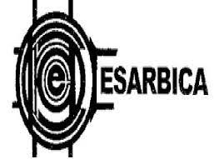 

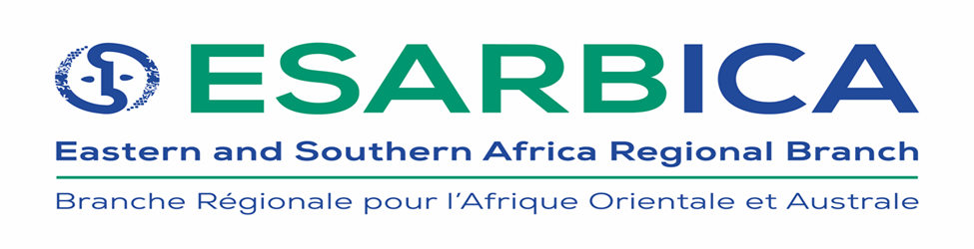

**ANNOUNCEMENT AND CALL FOR PAPERS FOR THE** **XXVIII ESARBICA CONFERENCE, 2025**

**HOST COUNTRY:** Zimbabwe, Elephant Hills Hotel in Victoria Falls

**CONFERENCE DATES:** 16th – 20th June 2025

Pre-conference: 16th -17th June 2025

Main conference: 18th -20th June 2025

**GENERAL THEME:** **Archives are Accessible — Archives for everyone**

This general theme is guided by the International Council on Archives (ICA)’s international theme for commemorating the International Archives Day. Therefore, ESARBICA invites submission of abstracts for its XXVIII conference to address issues around the following sub-themes:

1. Systems integration
2. Collaboration and cooperation
3. Repatriation of migrated archives
4. Sustainability (climate change)
5. International standards for records and archives management
6. Disruptive technologies
7. Archival access and accessibility in digital and physical spaces
8. Artificial intelligence in records and archives management
9. Community participation in archival programming

**IMPORTANT DATES:**

* Submission of abstracts: 10th March to 10th April 2025
* Notification of accepted abstracts: 19th April 2025
* Submission of complete paper: 10th June 2025

Please send abstracts to [esarbica2021@gmail.com](mailto:esarbica2021@gmail.com)